**Step-by-Step - Deploy of Rocket.Chat and API Interaction:**

1. **Docker Desktop Installation:**

- Downloaded Docker Desktop from the official website (https://www.docker.com/products/docker-desktop) and followed the installation instructions for Windows using WSL (Ubuntu).

2. **MongoDB Configuration with Docker:**

- Opened the PowerShell terminal and executed the command to create a MongoDB container:

```bash

docker run -d --name mongo-container -p 27017:27017 mongo

```

MongoDB Docker Container

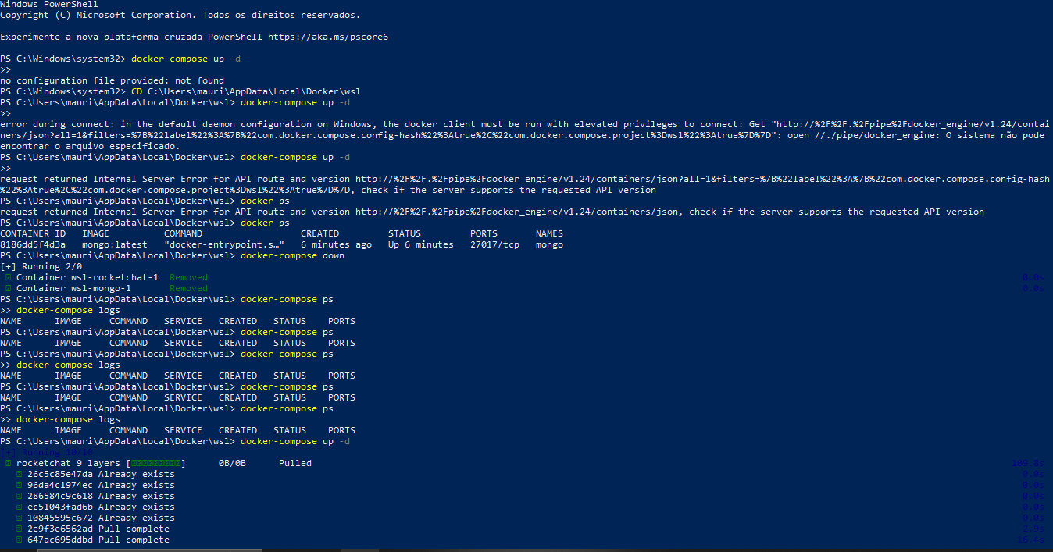3. **Rocket.Chat Installation with Docker:**

- Executed the command to create a Rocket.Chat container and link it to the MongoDB container:

```bash

docker run -d --name rocketchat-container -p 3000:3000 --link mongo-container:mongo rocket.chat

```

Rocket.Chat Docker Container

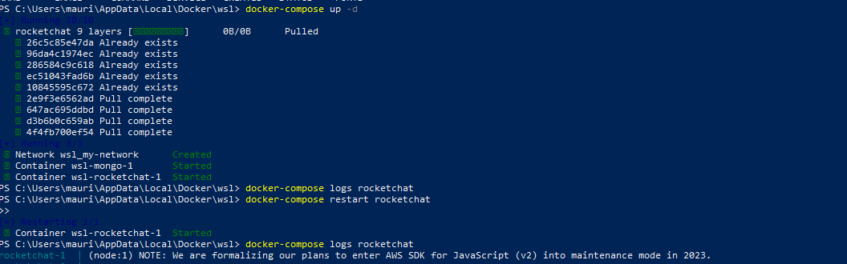

4. **Troubleshooting WSL and MongoDB Issues:**

- Encountered a connection issue between WSL and MongoDB. Used the `docker inspect mongo-container` command to obtain the MongoDB's IP address and adjusted the WSL configuration to connect using that IP.

The adjustment was made in the docker-compose.yml:

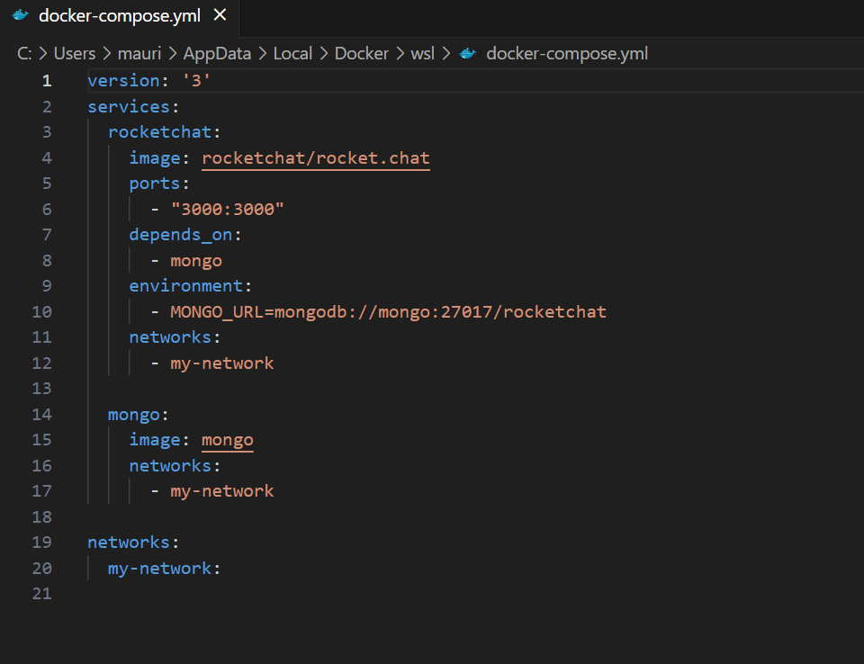

5. **Access to Rocket.Chat and Initial Configuration:**

- Opened a browser and accessed `http://localhost:3000`. Followed the instructions to set up the Rocket.Chat administrator.

6. **Resolution of "Bind for 0.0.0.0:3000 failed: port is already allocated" Error:**

- Discovered that port 3000 was in use by another service. Adjusted the port in the Docker command to resolve the issue.

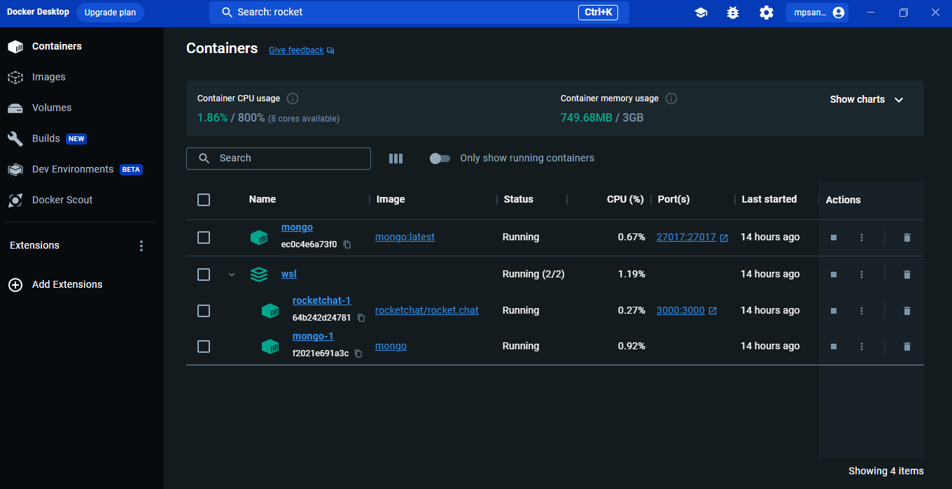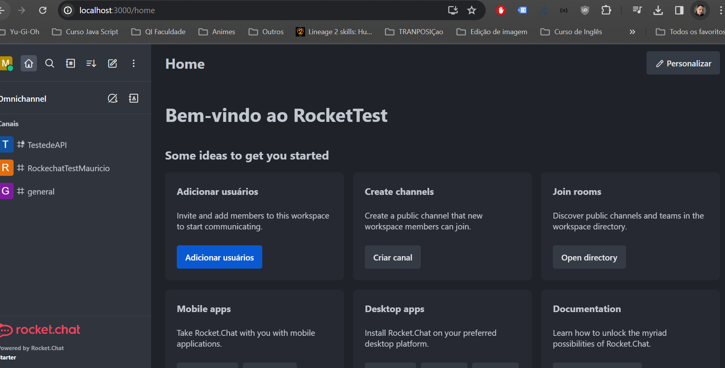

7. **Creation of a New User via API:**

- Used cURL to create a new user via API, utilizing the administrator's token and ID:

Postman collection link: [Postman Collection](https://elements.getpostman.com/redirect?entityId=16496781-6327d857-d1e1-458a-92f1-6c95f438007f&entityType=collection)

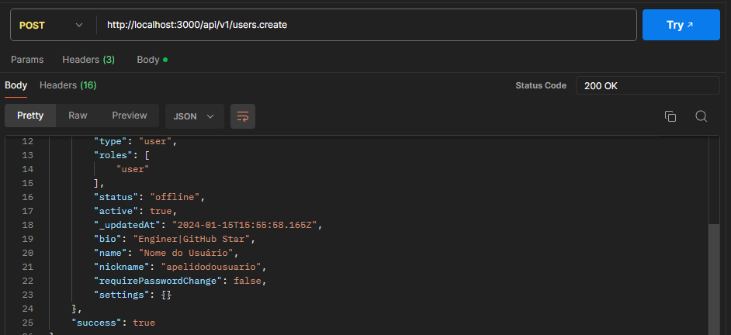

8. **Querying Room Information via API:**

- Used cURL to obtain information about a specific room:

Postman collection link: [Postman Collection](https://elements.getpostman.com/redirect?entityId=16496781-6327d857-d1e1-458a-92f1-6c95f438007f&entityType=collection)

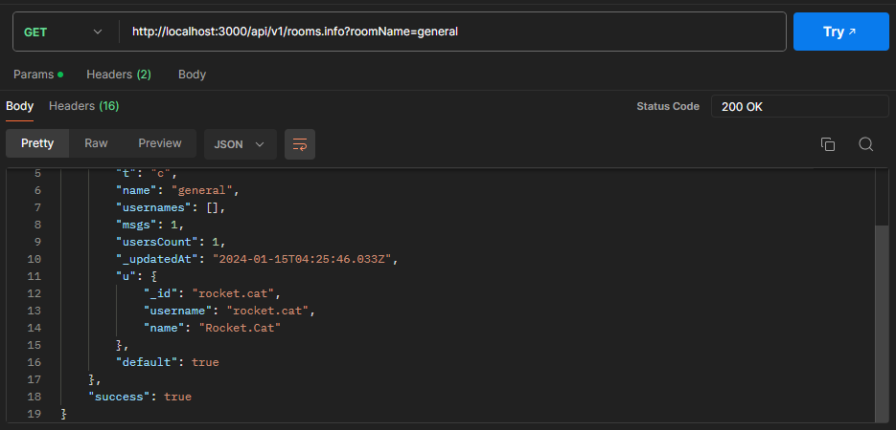

9. **Querying List of User Roles via API:**

Postman collection link: [Postman Collection](https://elements.getpostman.com/redirect?entityId=16496781-6327d857-d1e1-458a-92f1-6c95f438007f&entityType=collection)

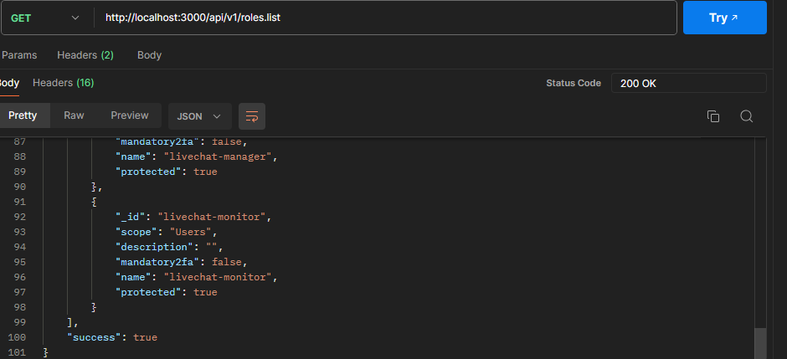

10. **Conclusion:**

- Completed the Rocket.Chat deployment process, troubleshooting, user creation via API, and information retrieval using the API. The environment is ready for evaluation.